2a. MASKING AND SETTING OF LOWER NIBBLES ON GIVEN DATA
Harini G
192524011
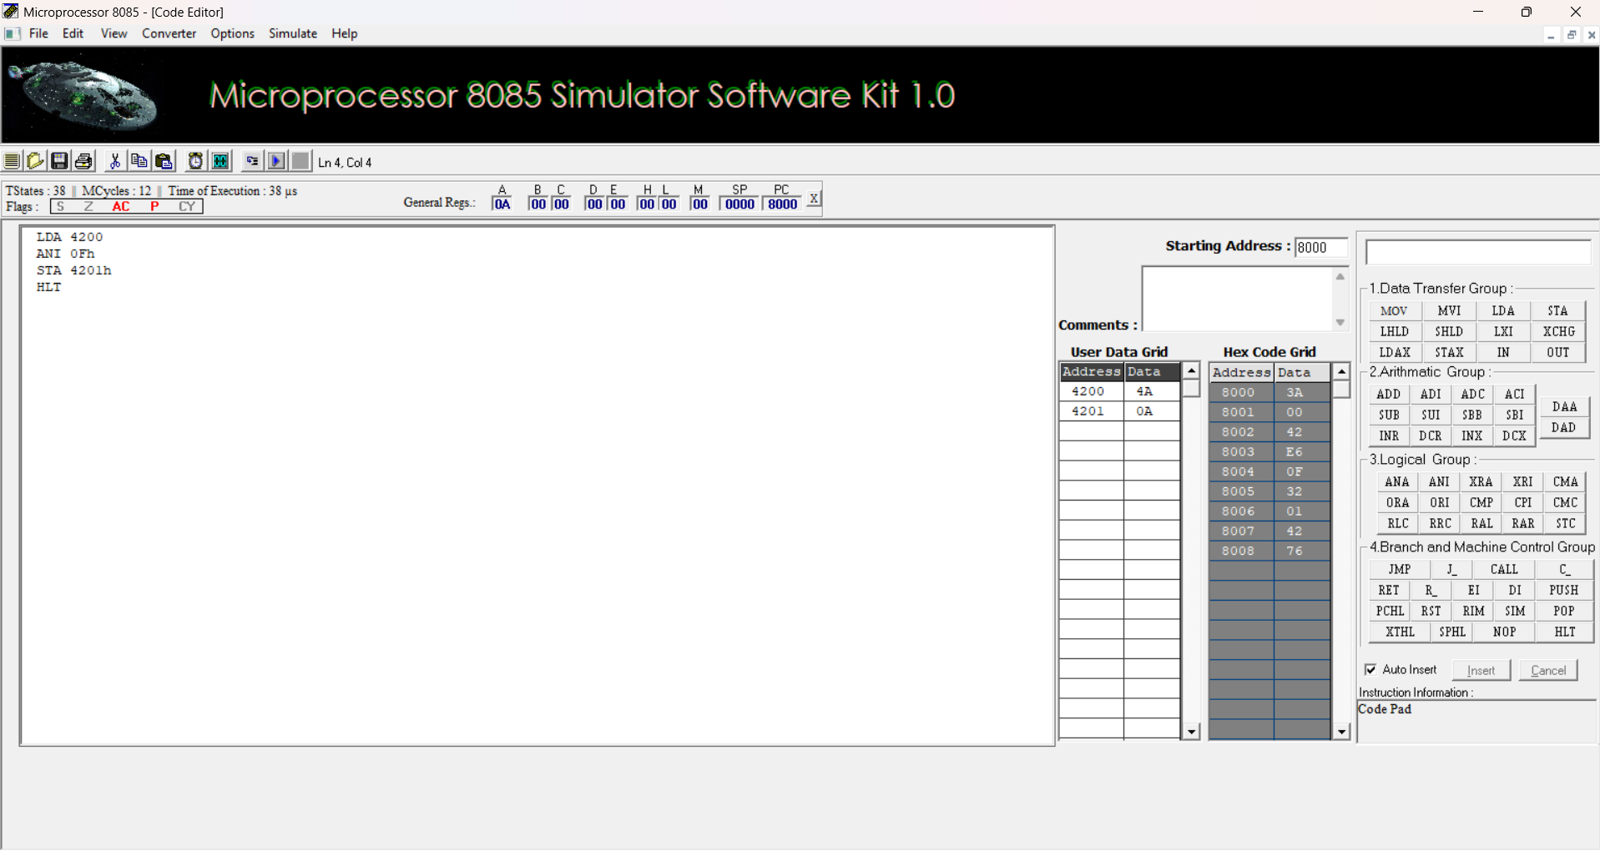
2b) SETTING OF BITS ALGORITHM:
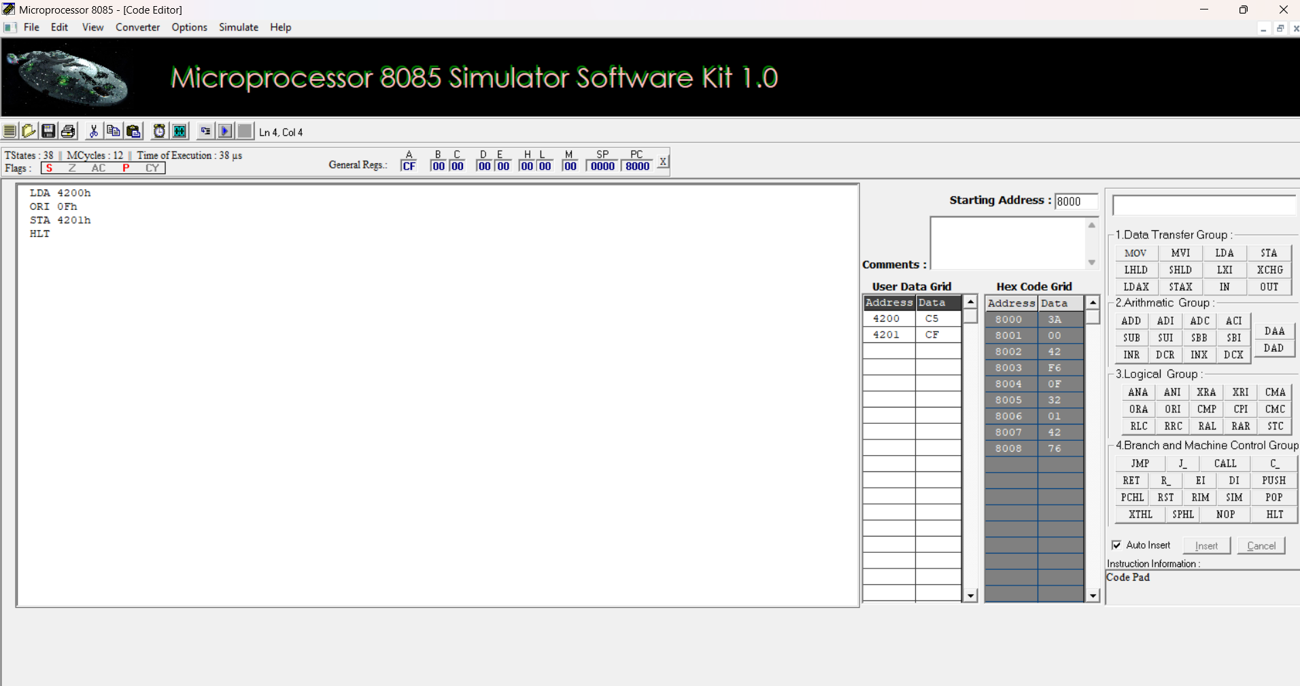

2c.ONE’S AND TWO’S COMPLEMENT
